

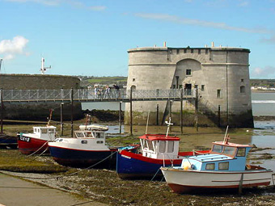

A week of action will be taking place in and around
Pembroke Dock
From 26th – 30th January 2009

To get involved please contact
Mari Williams
on 01646 681949 or e-mail mari.williams@keepwalestidy.org

